Title of Your Work (14pt Time Title of Your Work (14pt Times New Roman)
Member’s Names (11pt Times New Roman)
Affiliation, Country, e-mail (10.5pt Times New Roman)

Abstract
Here you write the overview of your product. The length of the abstract should be 200-300 words. In the beginning of the abstract, the subject of the paper should be stated clearly, together with its scope and objectives. Then, the methods, equipment, results and conclusions in the paper should be stated concisely in a sufficiently logical manner. (10pt Times New Roman)

Note: This is a sample template for proceeding. Please follow the format within two pages.
Background & Purpose
Here please state the background, purpose, and subject of your product briefly. (10pt Times New Roman)

Concept & Idea
Here please explain the concept and idea of your product in detail. (10pt Times New Roman)
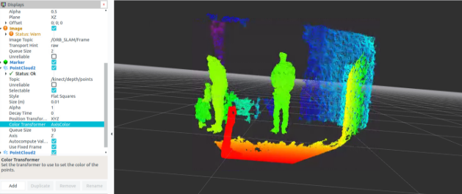
Fig. 1 The depth information from depth-camera

Design & Functions
Here please explain the design and function of your product in detail. (10pt Times New Roman)

Problems & Future work
Here please state problems to solve in your future work simply. (10pt Times New Roman)

